ASSIGNMENT 5

Q.1 Objective: Configure Static Route in Cisco packet tracer
• Static route tells the device exactly where to send traffic, no matter what.
• Static route is often used when your network has only a few routers or there is only one
route from a source to a destination.
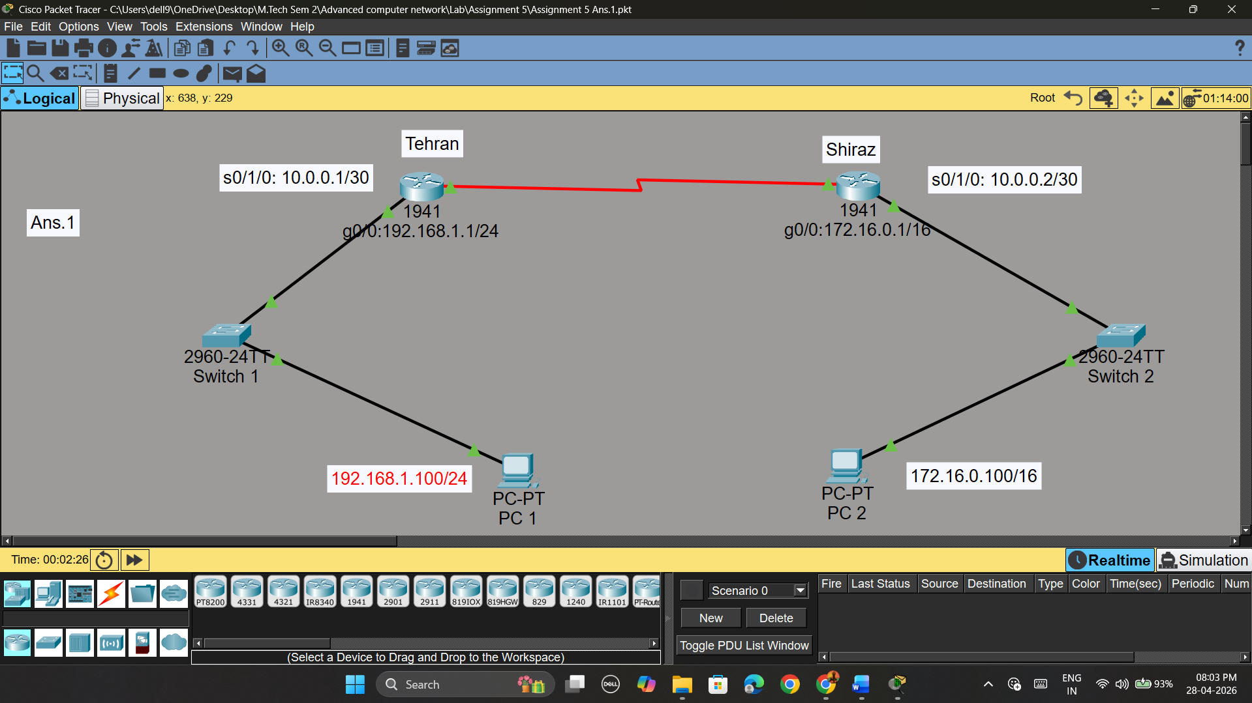

Q.2 Suppose you want to create 3 subnets of a network having network address
198.168.1.0. In another network with network address 220.168.2.0, you want to
create 2 subnets. For this scenario configure the end devices and routers
accordingly. Connect two different networks (both are subnetted) through static
routing and show the message transmission among hosts of the two networks

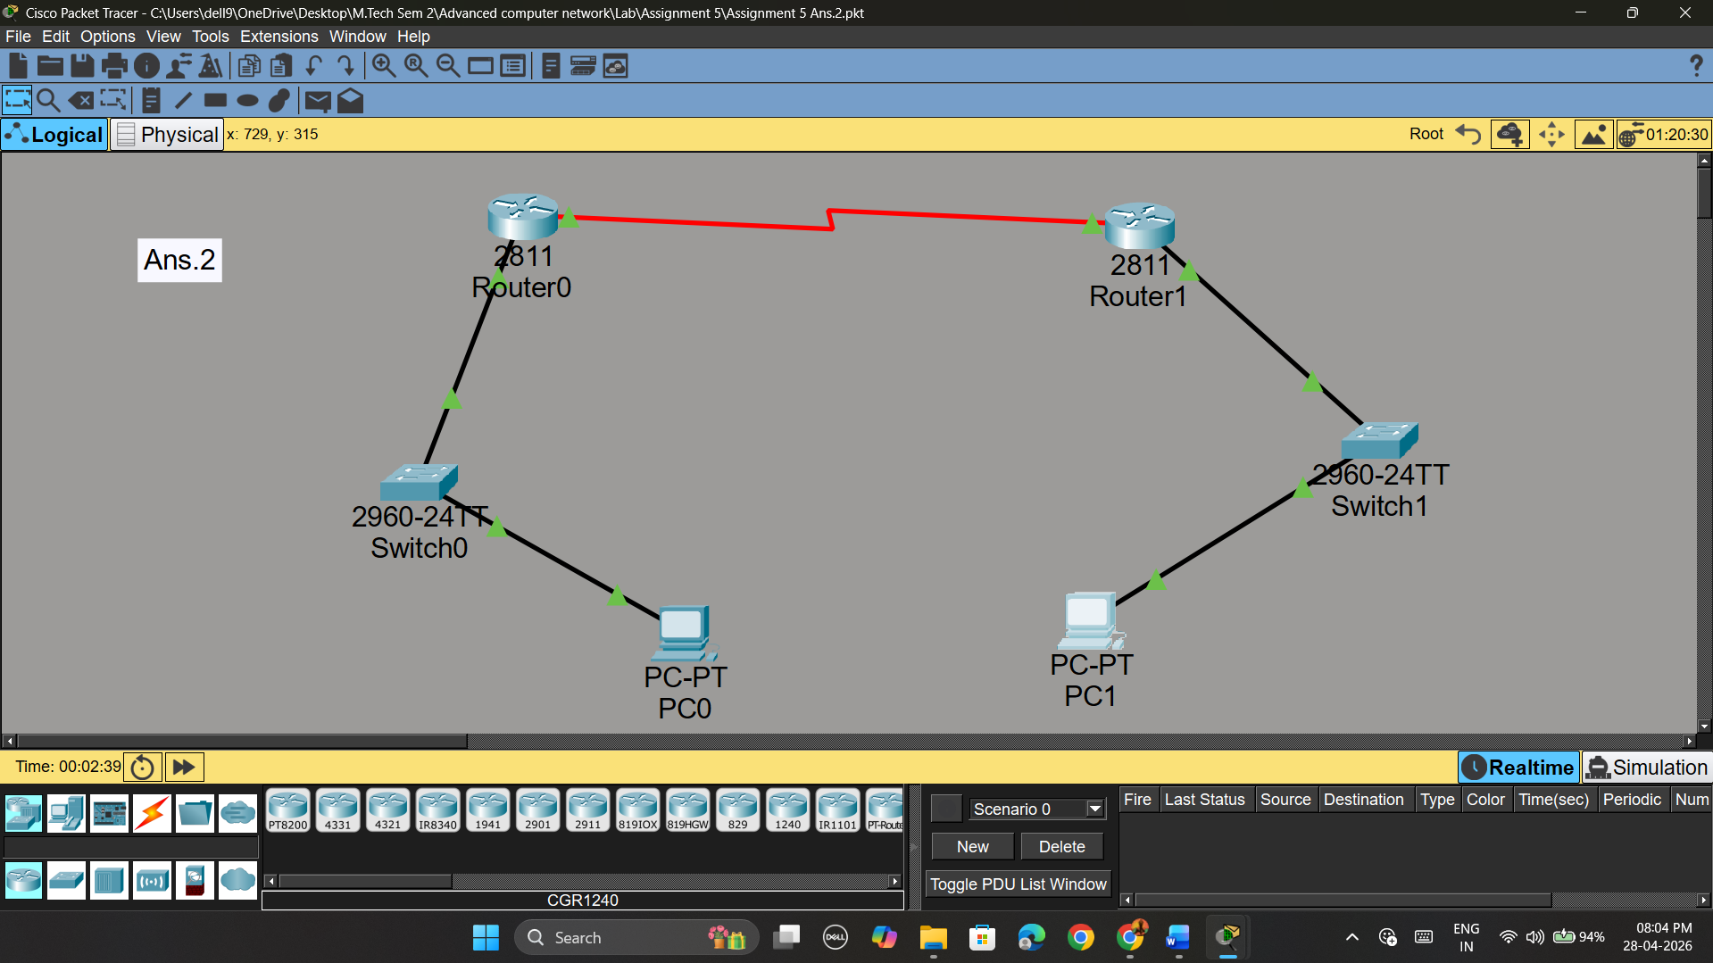

Q.3. Connect two networks having network address 192.168.3.0 and 224.152.1.0
respectively. Network 1 having 4 and network two having 3 hosts. Connect two
different networks through a router. For this scenario configure the end devices
and routers accordingly and show the message transmission among hosts of the
two networks.

